CLOUD COMPUTING

ASSIGNMENT – 1

Submitted By:-

R PRANAV
MCA S2
ROLL NO:46

Hosting a Custom Website on AWS EC2 using Apache

1)Aim
To host a custom website on an Ubuntu EC2 instance using Apache Web Server and make it accessible via public IPv4.
2) Requirements
- AWS Account (Amazon Web Services)
- Ubuntu EC2 Instance
- Apache Web Server
- Portfolio Website (HTML, CSS, assets)
- SSH client
3) Project Structure
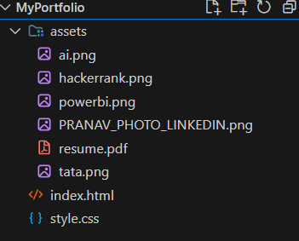
4) Procedure
Step 1: Launch EC2 Instance
- Login to AWS Console
- Go to EC2 Dashboard
- Click Launch Instance
Configure:
- Name: MyPortfolioServer
- AMI: Ubuntu Server 22.04
- Instance Type: t3.micro
- Key Pair: Create/download .pem
- Network Settings:
  - Allow SSH (22)
  - Allow HTTP (80)
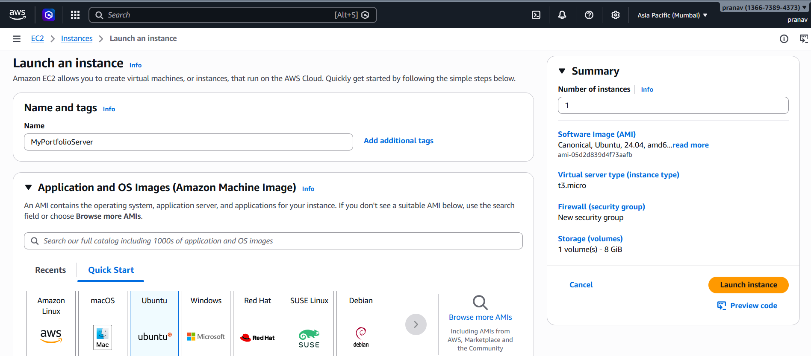
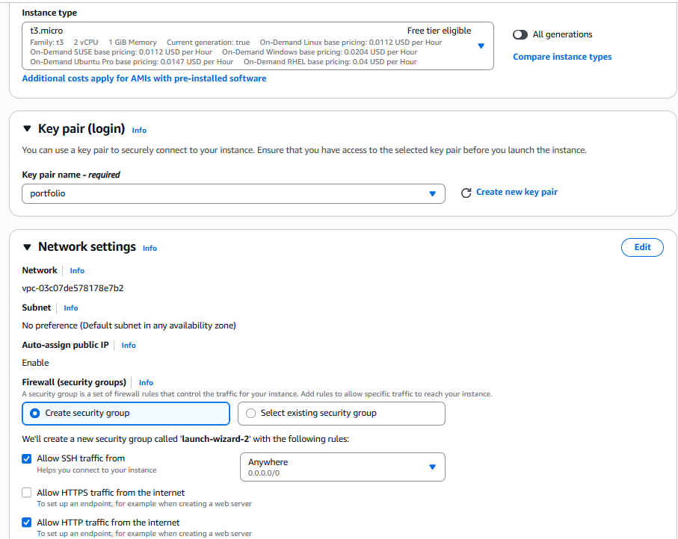
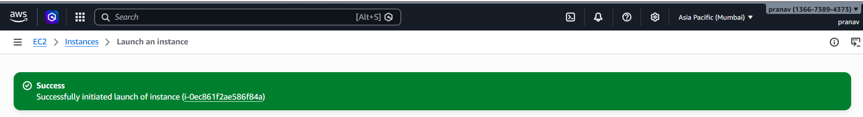
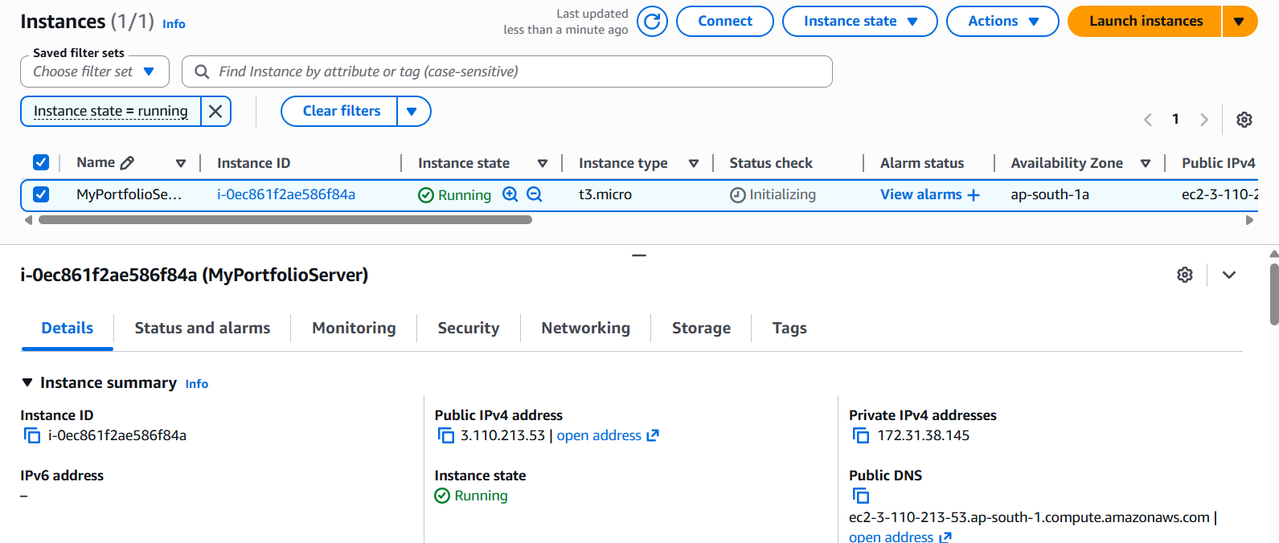
Step 2: Connect to Instance (SSH)
Open terminal:

ssh -i "C:\Users\LENOVO\Downloads\portfolio.pem" ubuntu@3.110.213.53
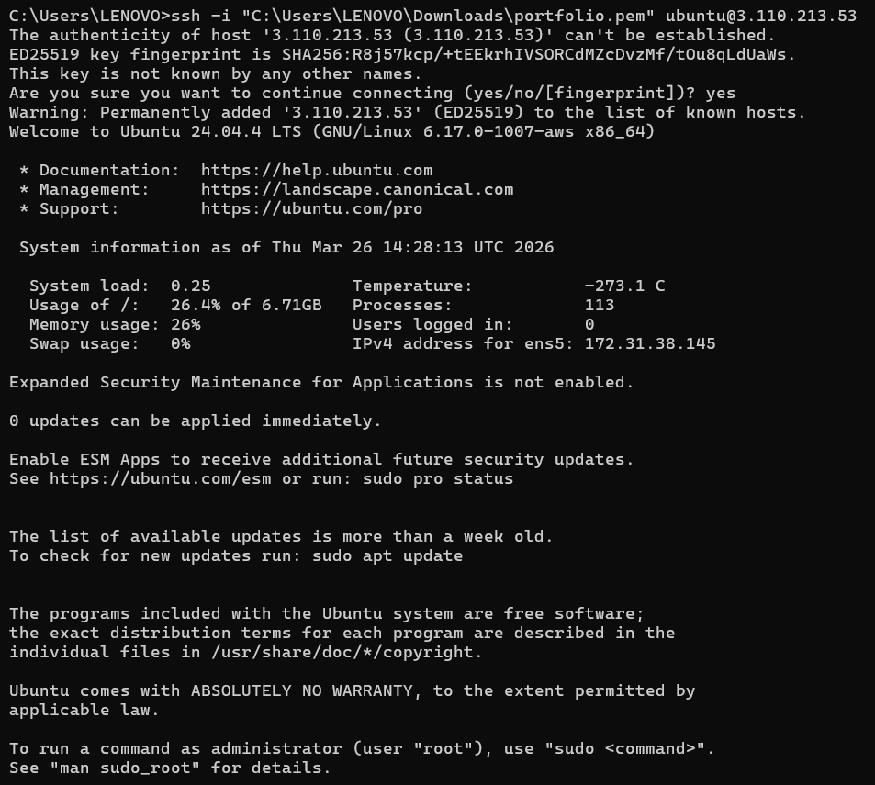

Step 3: Install Apache Web Server
Run:
sudo apt update
sudo apt install apache2 -y

Start Apache:
sudo systemctl start apache2
sudo systemctl enable apache2

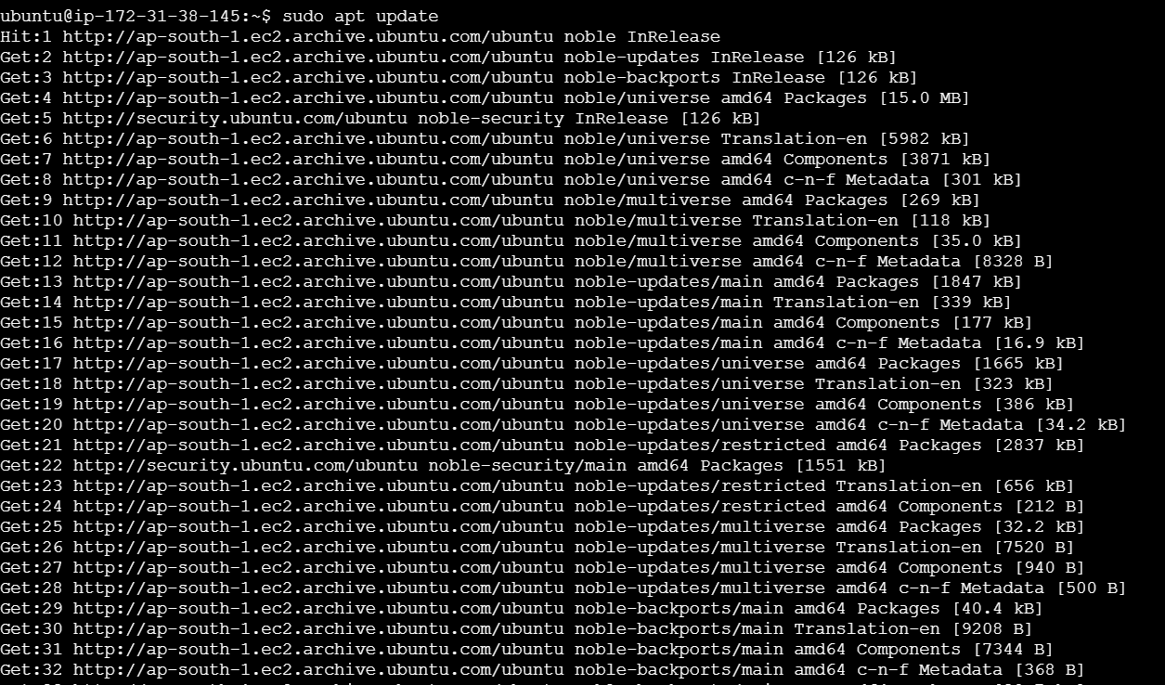

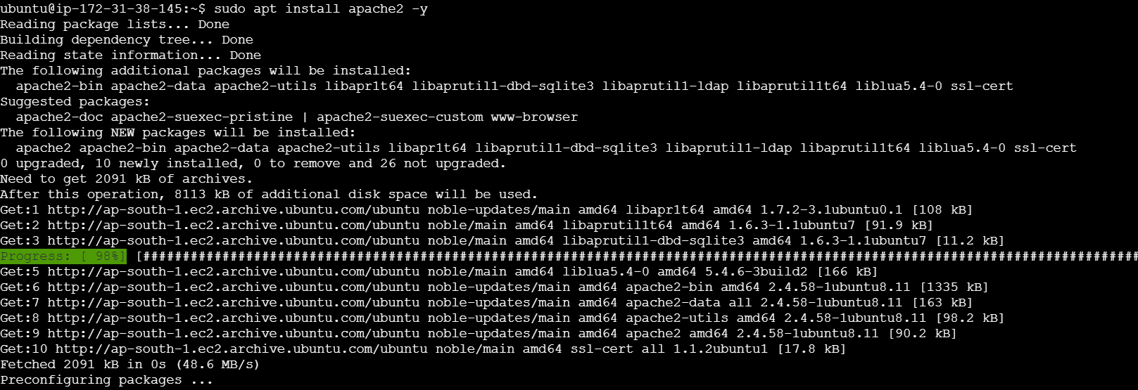

Step 4: Verify Apache Installation
Open browser:
http:// 3.110.213.53

You should see Apache default page.
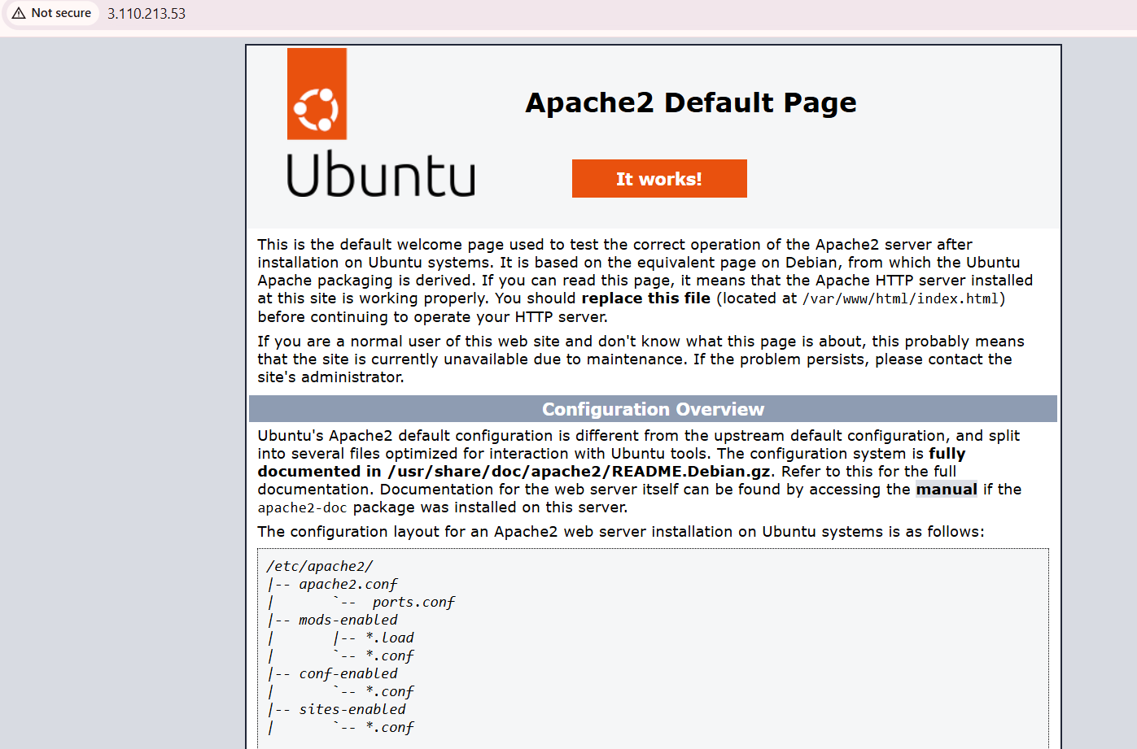
Step 5: Upload Website Files
The website files were transferred securely from the local system to the EC2 instance.
Open Command Prompt
Navigate to your project directory:

cd "C:\Users\LENOVO\OneDrive\Desktop"

Execute SCP command:
scp -i "C:\Users\LENOVO\Downloads\portfolio.pem" -r "C:\Users\LENOVO\OneDrive\Desktop\MyPortfolio" ubuntu@3.110.213.53:/home/ubuntu

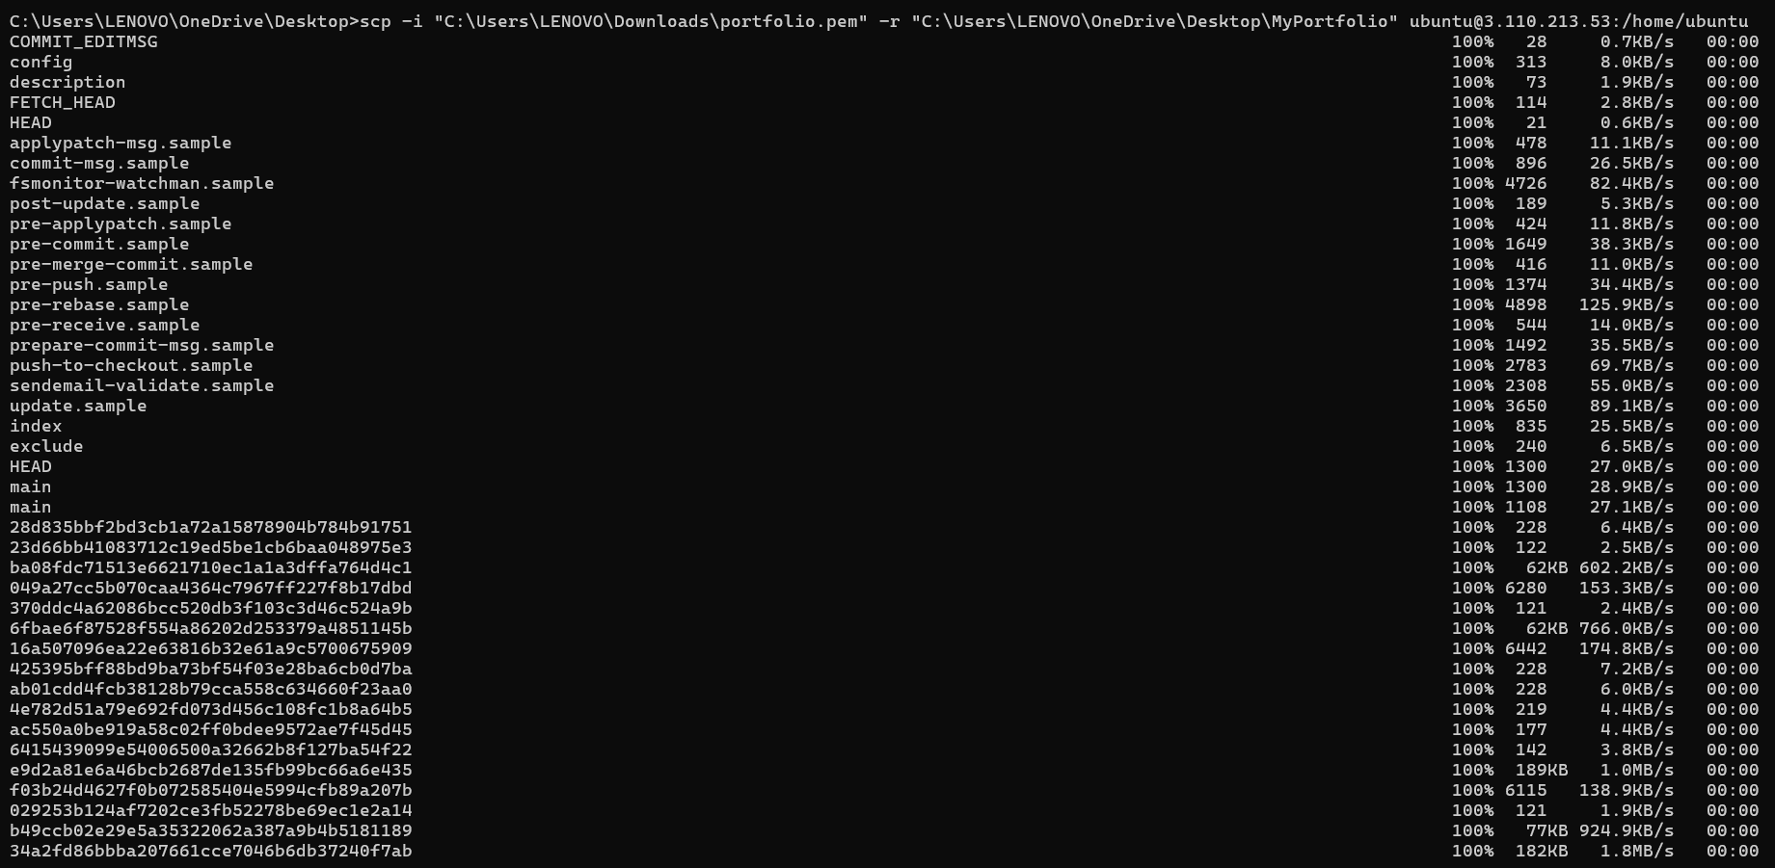
Step 6: Move Files to Apache Web Directory
After successfully uploading the project using SCP, connect to the EC2 instance using SSH:
ssh -i "C:\Users\LENOVO\Downloads\portfolio.pem" ubuntu@3.110.213.53

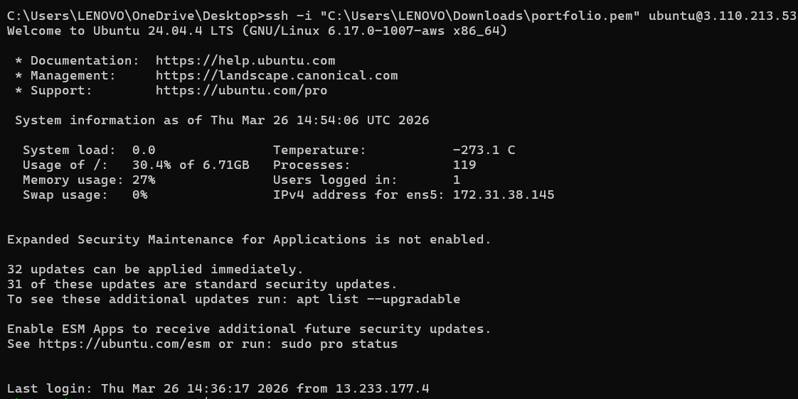
Navigate to the uploaded project folder:
cd /home/ubuntu/MyPortfolio
Copy website files to Apache root directory:
sudo cp -r * /var/www/html/

Remove default Apache index file (if present):
sudo rm /var/www/html/index.html

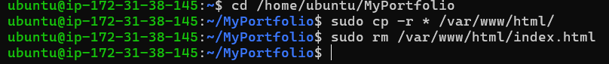
Step 7: Set File Permissions
Assign proper permissions to ensure the web server can access the files:
sudo chmod -R 755 /var/www/html

Step 8: Verify Uploaded Files
Check whether the files are correctly placed:
ls /var/www/html

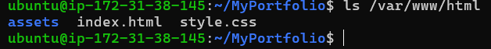
Step 9: Access Hosted Website
Open a web browser and enter:
http://3.110.213.53
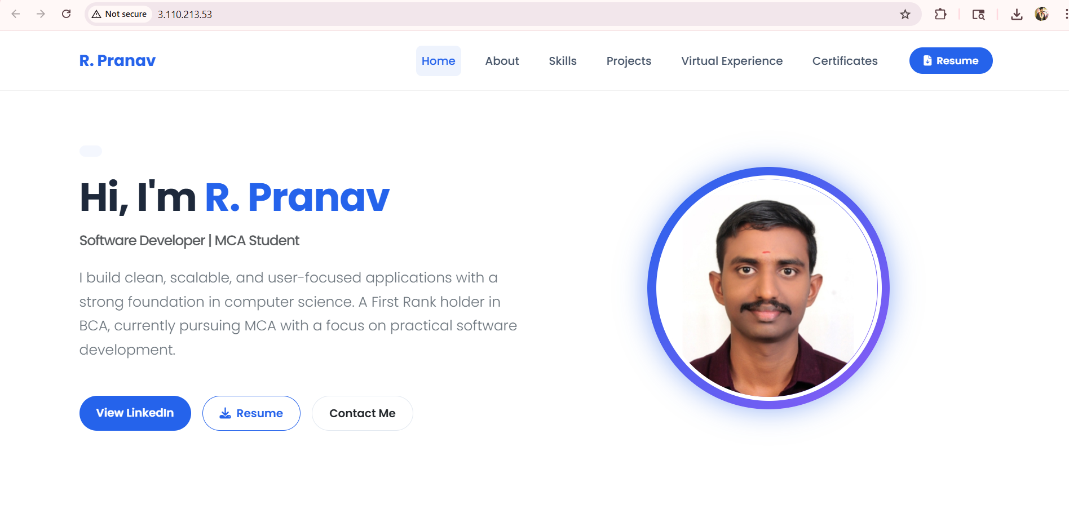
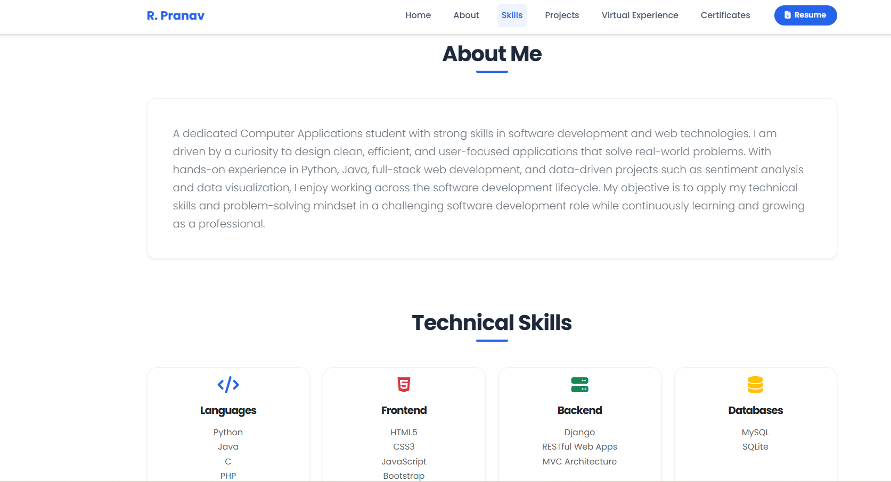
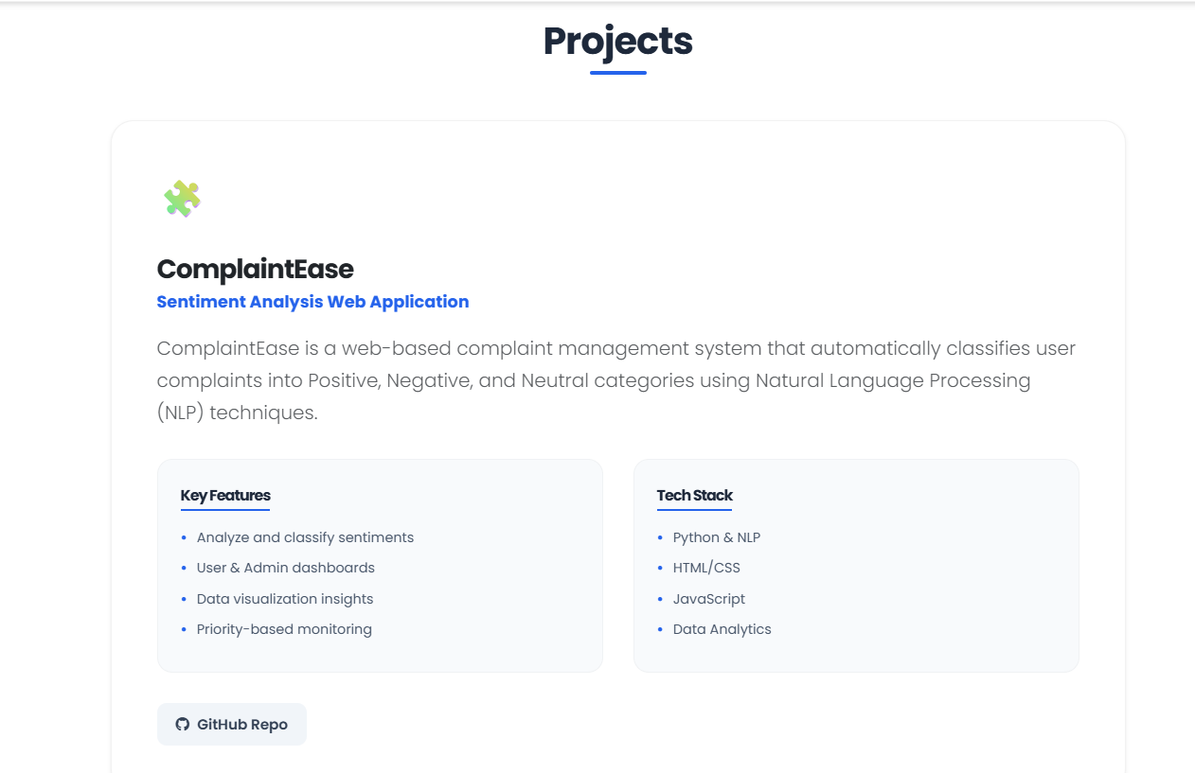



Step 10: Result
The custom website was hosted on an Ubuntu EC2 instance using Apache web server, and the files were transferred securely using SCP.

